RETAIL SALES & INVENTORY ANALYTICS PLATFORM
Professional Project Report

Microsoft Fabric • OneLake • PySpark • Power BI

Project Type | End-to-End Retail Analytics Platform
Primary Platform | Microsoft Fabric
Processing | Fabric Notebook / PySpark
Analytics Layer | Gold Product KPIs
Visualization | Power BI
Report Purpose | GitHub-ready project documentation

1. Project Overview
The Retail Sales & Inventory Analytics Platform is an end-to-end analytics solution implemented using Microsoft Fabric. The project brings together retail Orders, Returns and Inventory data, ingests the source data into Fabric, processes it using PySpark, organizes the data through Bronze, Silver and Gold layers, and presents business-ready product-level analytics through Power BI.
The final solution is designed to make retail performance easier to monitor by combining sales, returns, inventory and profitability information in a structured analytical workflow.

2. Project Objectives
- Store the retail source datasets in a structured Microsoft Fabric environment.
- Create a Bronze layer for raw source data.
- Clean, standardize and transform data through the processing layers.
- Create Gold-level product KPIs for business analysis.
- Connect the analytical Gold data to Power BI.
- Build an interactive dashboard for sales, profitability, returns and inventory analysis.

3. Solution Architecture
Source Data → Bronze → Silver → Gold → Power BI
The architecture follows a layered lakehouse approach. Orders, Returns and Inventory form the source datasets. Raw data is first ingested into Bronze, cleaned and standardized through the processing layer, and then transformed into Gold-level analytical outputs. Power BI consumes the business-ready Gold data for reporting.

4. Step-by-Step Implementation

Step 1 — Source Data Storage
The project begins with the retail source datasets. Orders, Returns and Inventory are kept as the input data for the analytics pipeline.
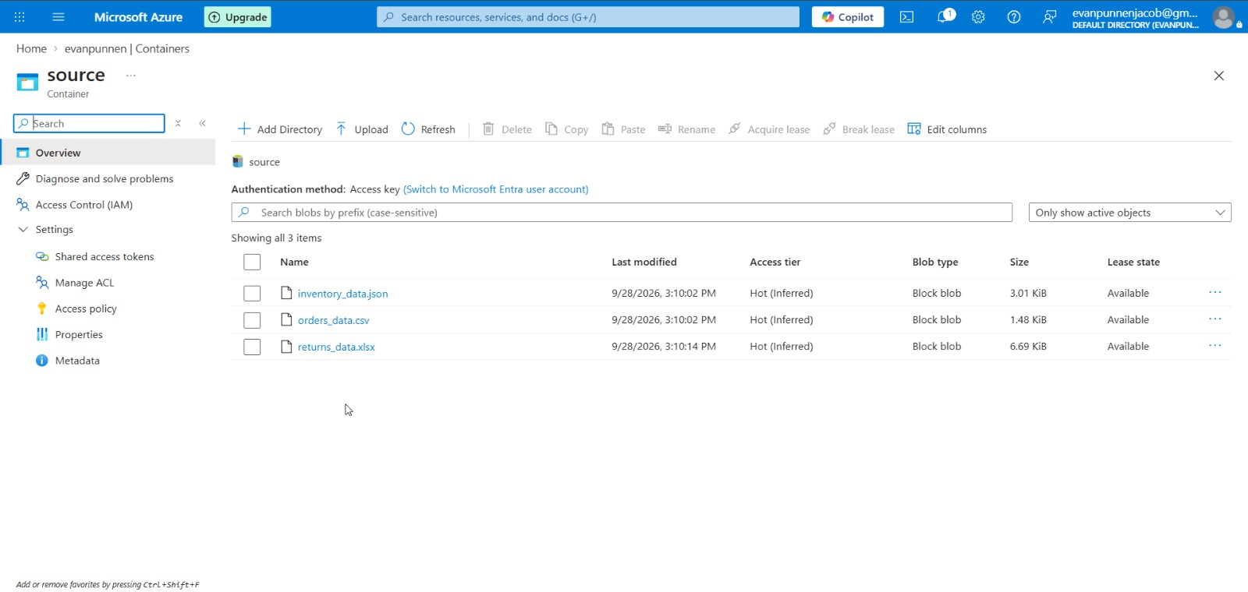
Figure 1. Project source area showing the retail input files used for the analytics solution.

Step 2 — Microsoft Fabric Workspace Setup
A Microsoft Fabric workspace is prepared for the project. The workspace provides the environment for pipelines, notebooks, lakehouse storage and reporting.
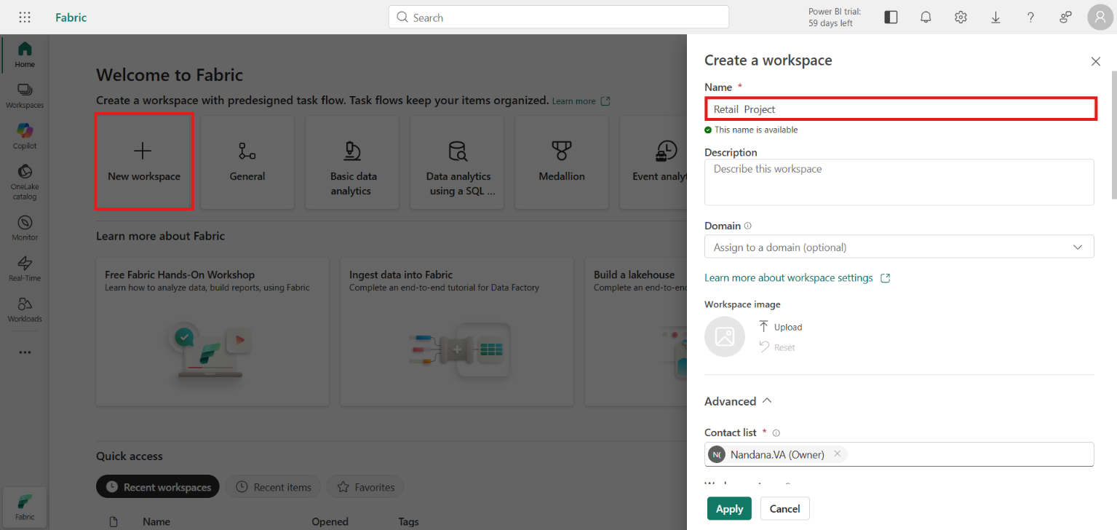
Figure 3. Microsoft Fabric workspace creation screen for the retail analytics project.

Step 3 — Pipeline Creation
A Fabric data pipeline is created to automate ingestion of the project datasets into the Fabric environment.
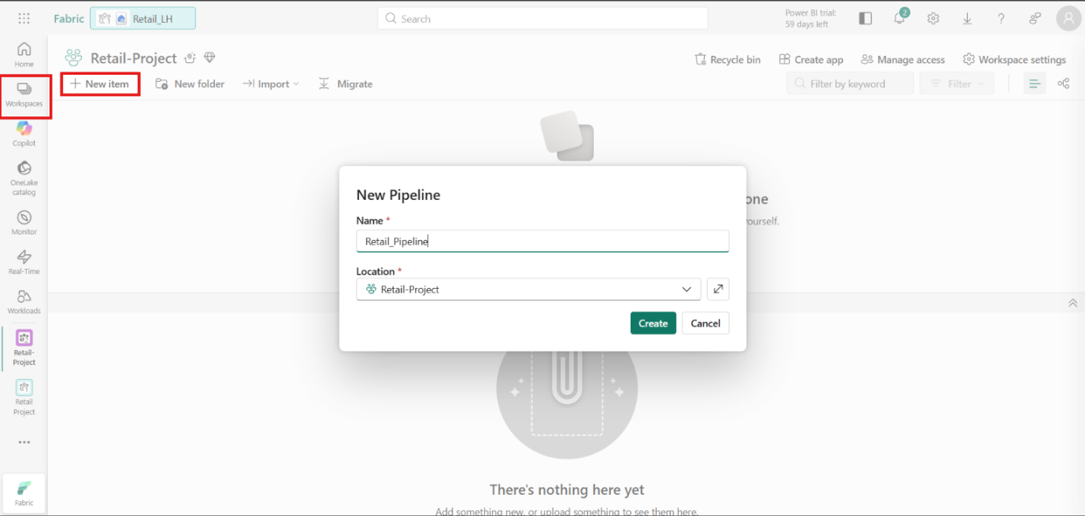
Figure 4. Creation of the Fabric data pipeline used to move project data into the analytics environment.

Step 4 — Source and Connection Configuration
The required storage, connection and access settings are configured so that the pipeline can read from the project source and write the data to the intended destination.
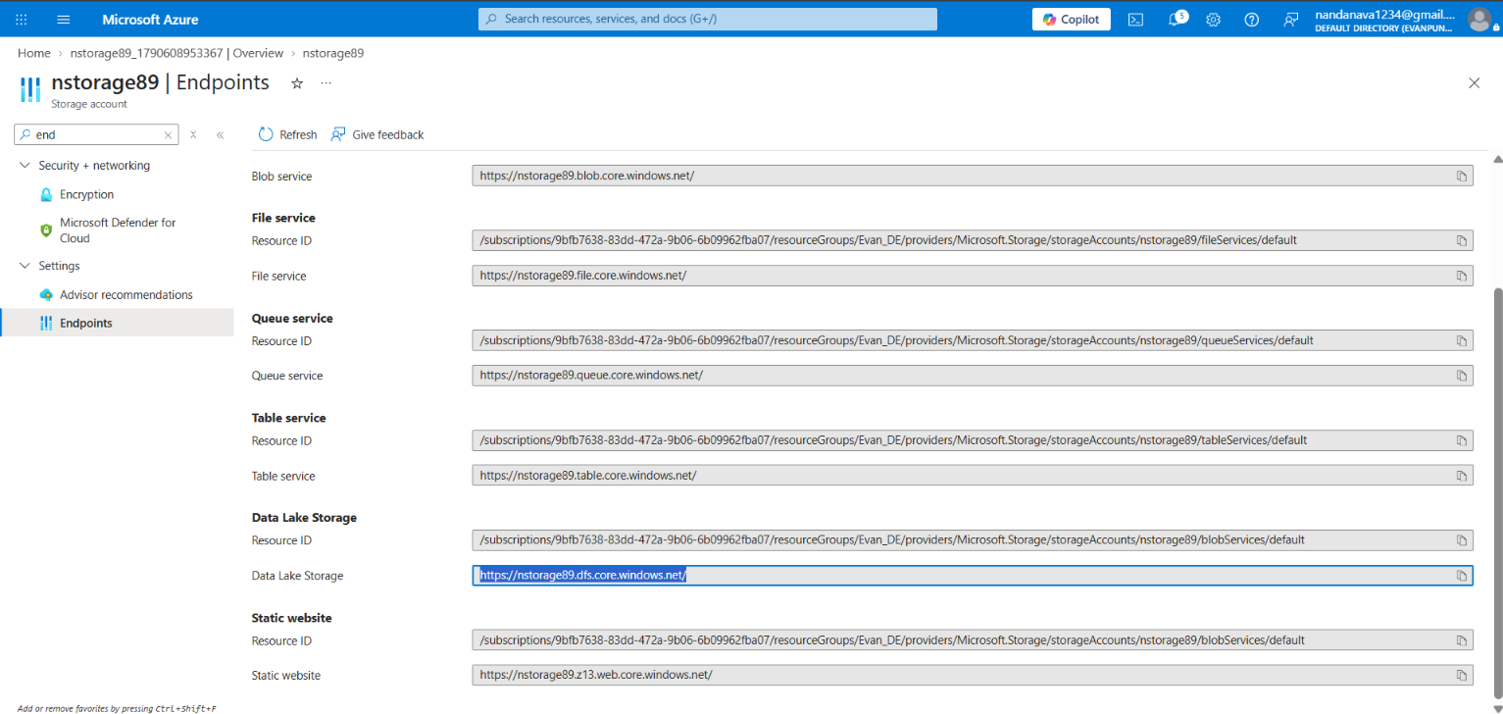
Figure 5. Fabric storage / endpoint configuration used during project setup.
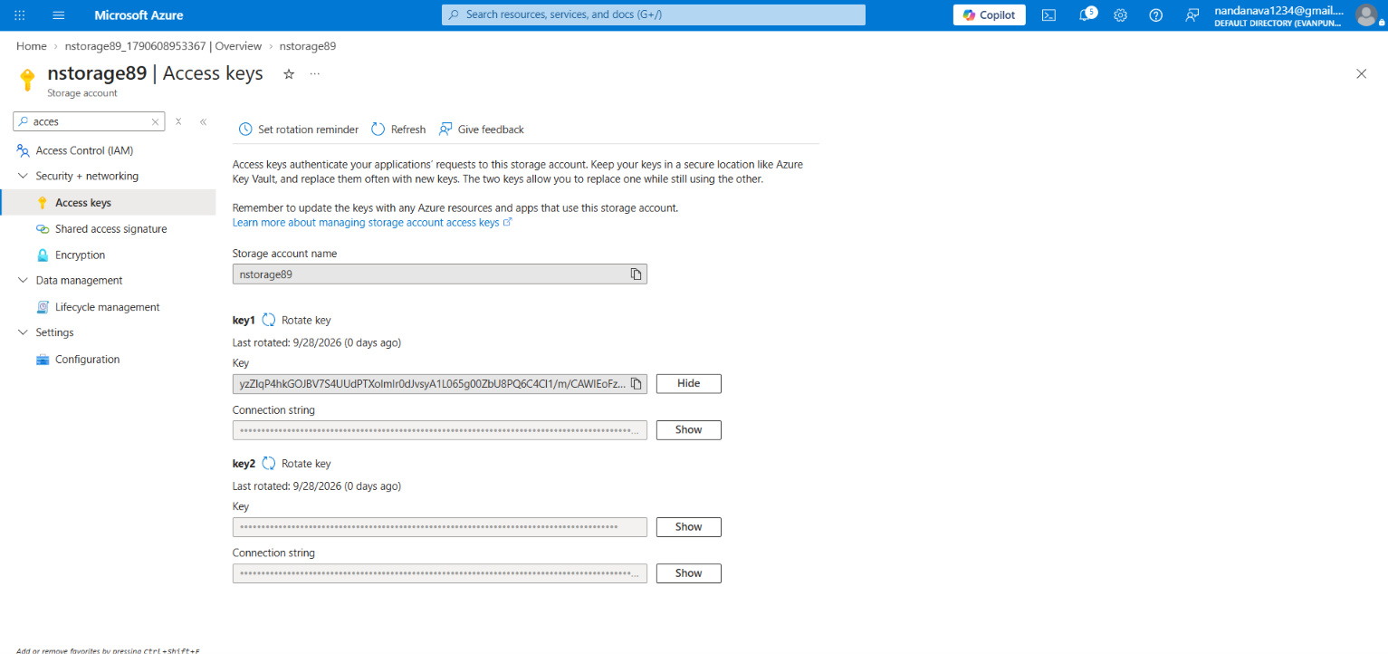
Figure 6. Access and connection configuration for the project data source.
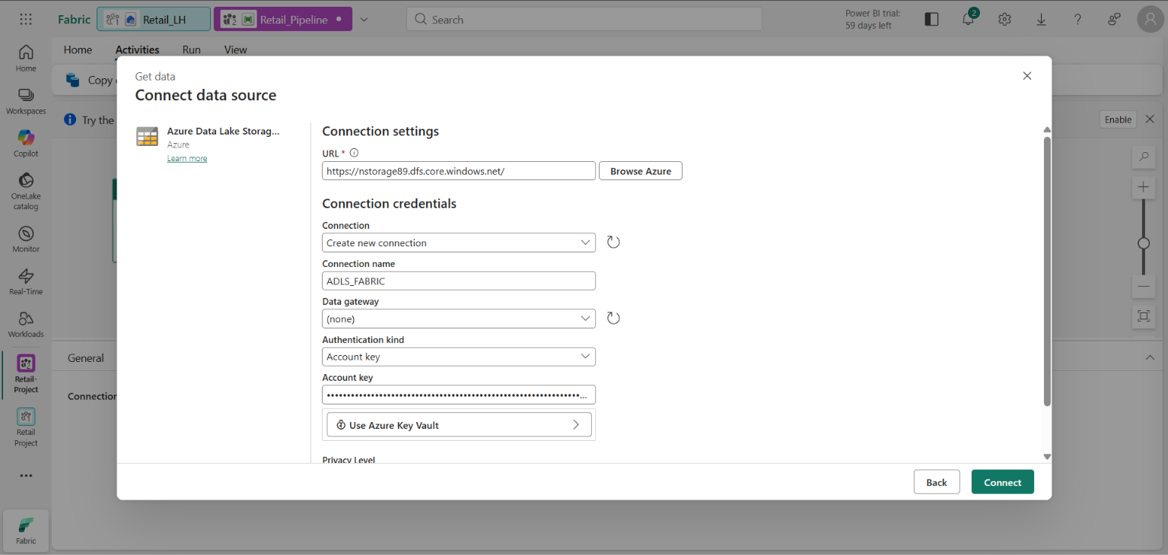
Figure 7. Connect-data-source dialog used to establish the required source connection.

Step 5 — Pipeline Data Flow
The source and destination activities are configured for the retail datasets. The pipeline is then executed to load the data.
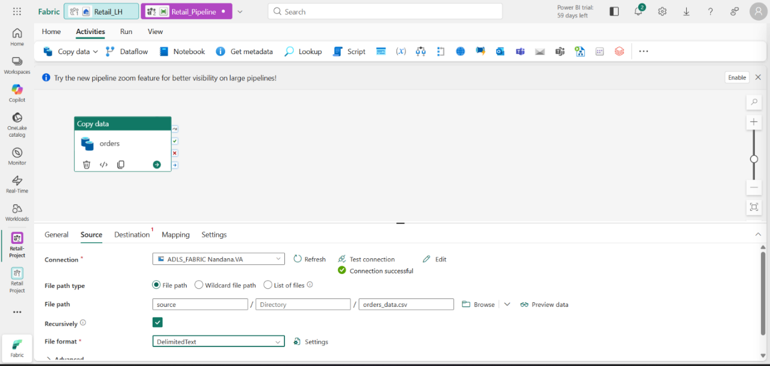
Figure 8. Pipeline source configuration for ingesting the retail datasets.
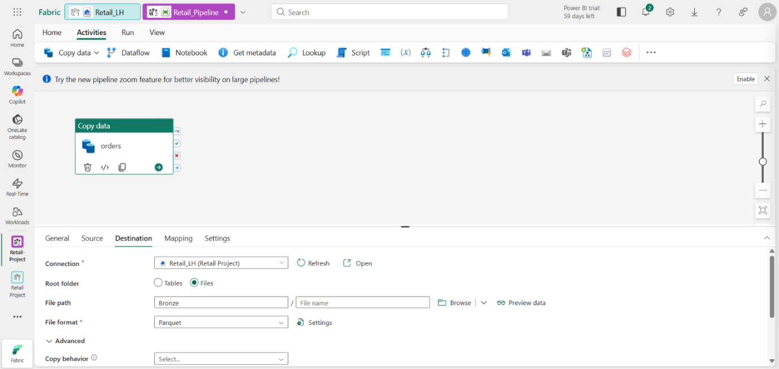
Figure 9. Pipeline destination configuration for loading data into Fabric storage.

Step 6 — Pipeline Validation
The pipeline run is checked after execution. The supplied screenshot shows the ingestion workflow completing successfully.
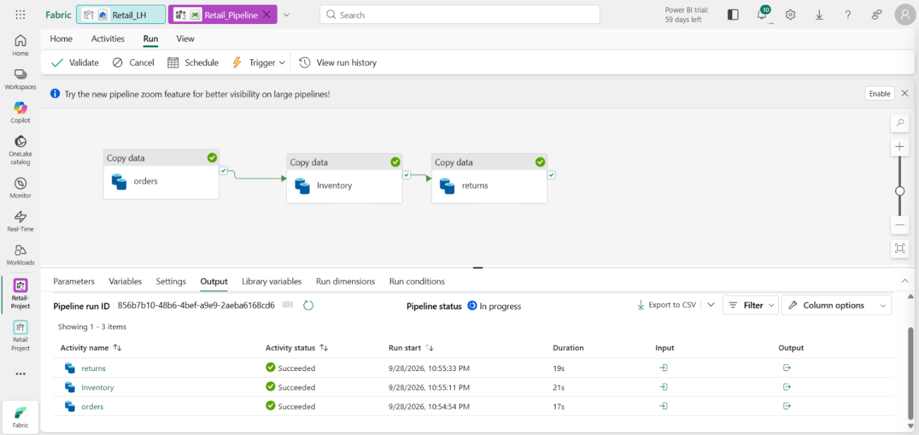
Figure 10. Successful pipeline execution showing the completed ingestion activities.

Step 7 — Notebook and PySpark Processing
A Fabric Notebook is used for data inspection and PySpark-based processing. The notebook workflow loads the project data and prepares it for analytical transformation.
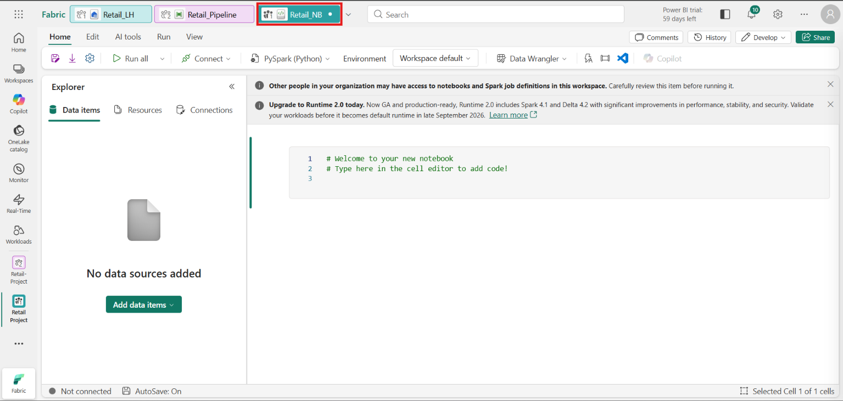
Figure 11. Fabric Notebook workspace prepared for PySpark-based data processing.
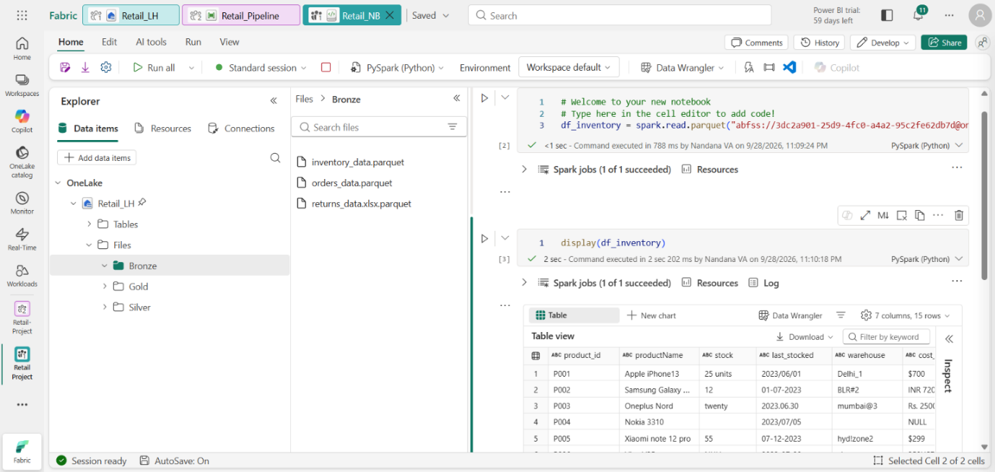
Figure 12. Notebook code and data-processing view used to load and inspect project data.
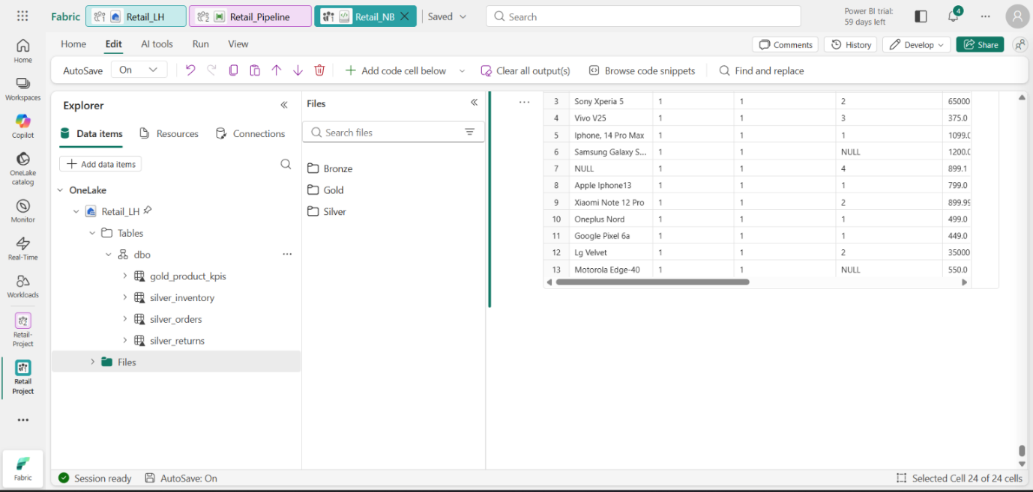
Figure 13. Notebook output showing the loaded dataset and its columns/records.

Step 8 — Data Transformation and Analytical Layers
The processing workflow applies the required transformations and produces validated analytical outputs. The supplied notebook and table screenshots document the transformation and resulting datasets.
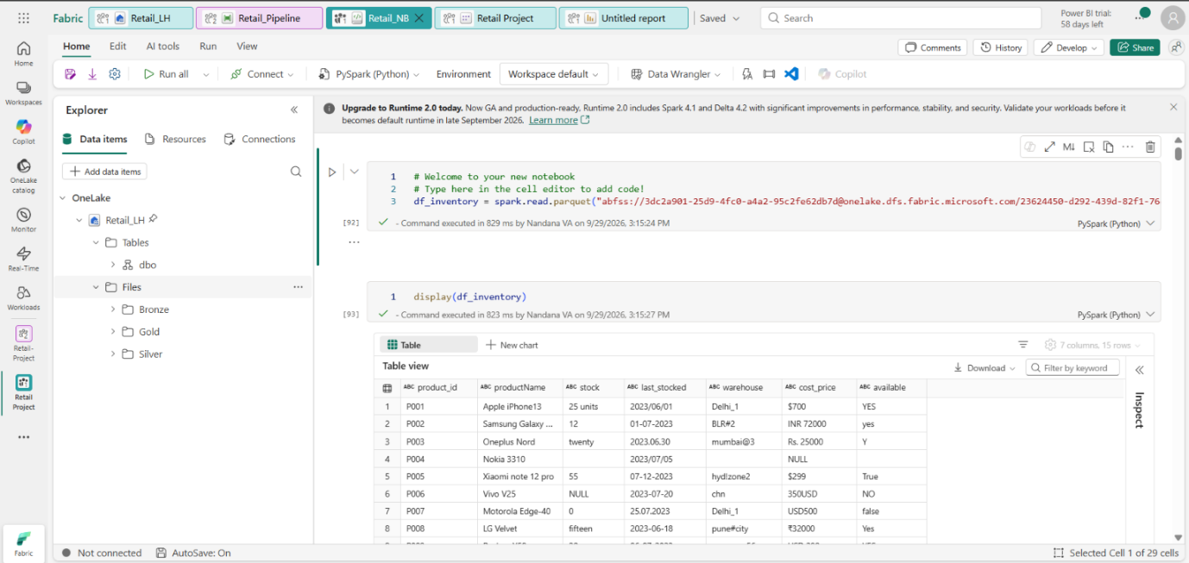
Figure 14. Data-processing notebook view showing transformed retail data.
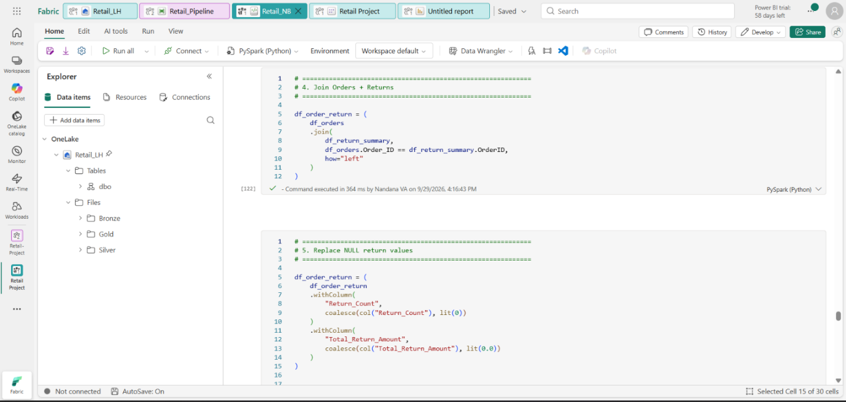
Figure 15. PySpark transformation logic used in the analytics workflow.
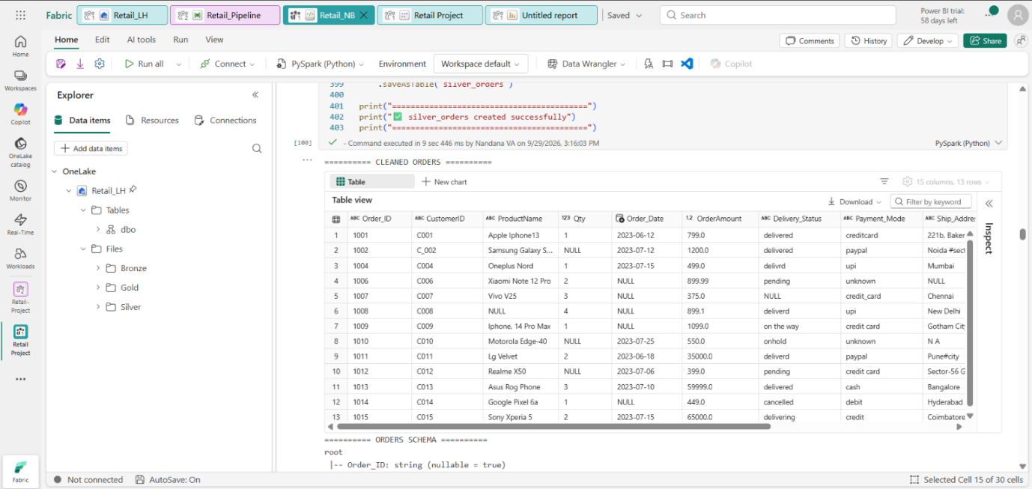
Figure 16. Processed dataset output used to validate the transformation results.
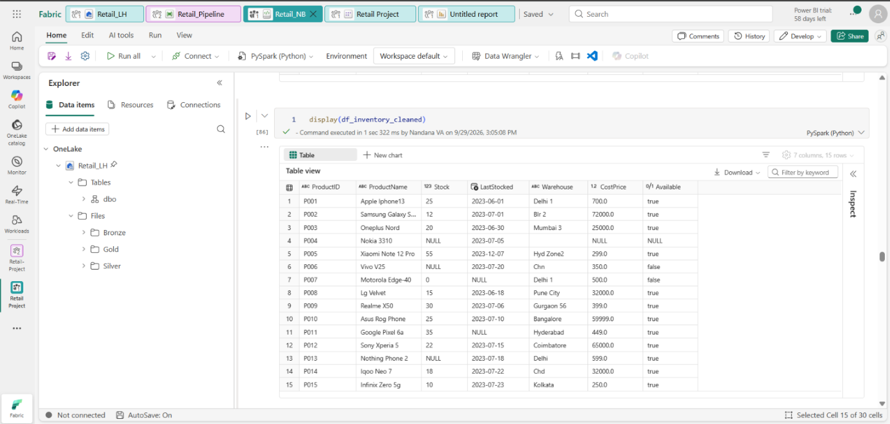
Figure 17. Additional processed-data validation view from the Fabric Lakehouse.
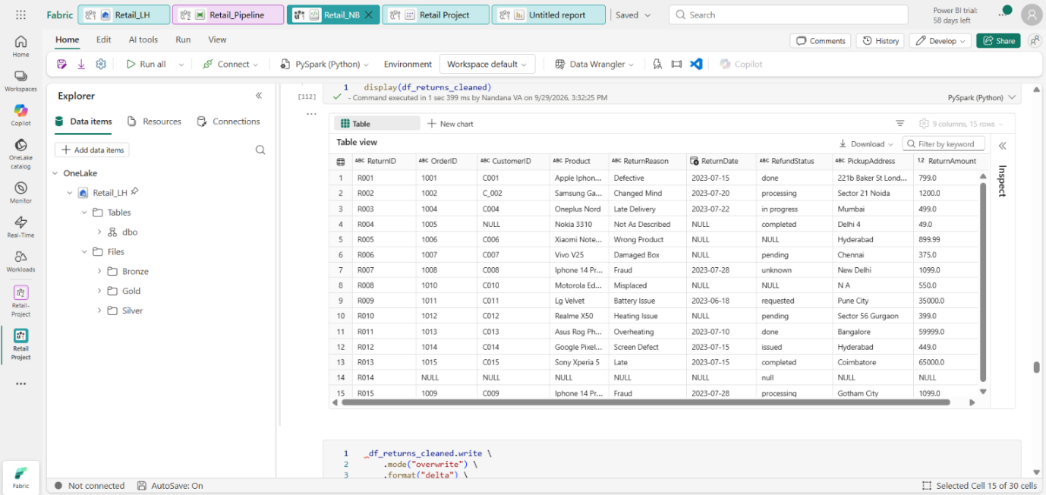
Figure 18. Final processed table/output used for downstream analytics.

Step 9 — Power BI Model
The processed analytical data is made available to Power BI. The model view provides the fields required for reporting and dashboard creation.
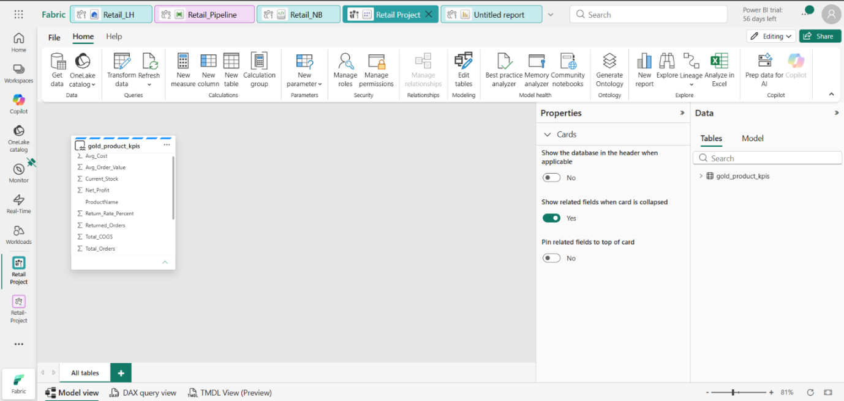
Figure 19. Power BI Model view showing the analytical table and available fields.

Step 10 — Final Power BI Dashboard
The final dashboard presents the retail sales performance results in an interactive visual format for business analysis.
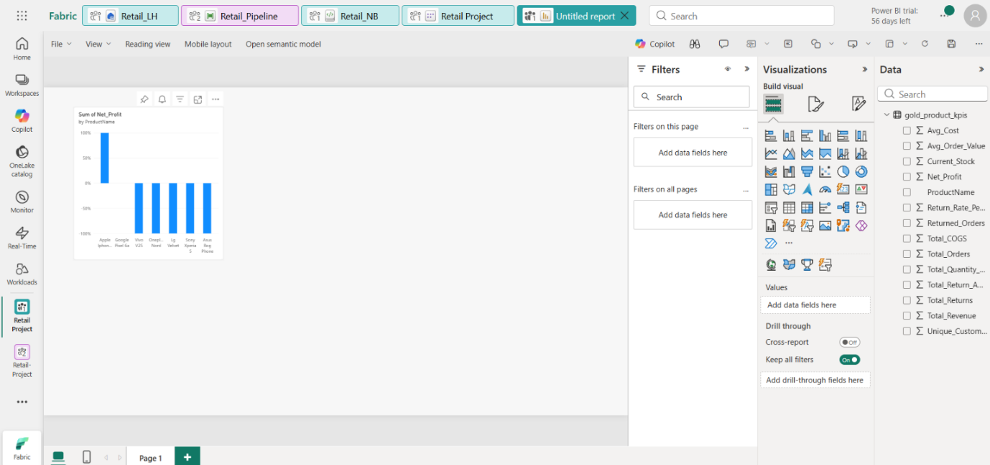
Figure 20. Final Retail Sales Performance Dashboard used for business analysis.

5. Gold-Layer KPI Calculations
The Gold analytical layer is designed around product-level business metrics. The core calculations documented for the project are:
KPI | Calculation / Meaning
COGS | Quantity × Cost Price
Net Profit | Order Amount − COGS
Return Rate % | (Returned Orders ÷ Total Orders) × 100
Profit_Status | Identifies Profit, Loss, Cost Data Missing or Quantity Missing conditions
Returns are aggregated by Order ID before joining with Orders so that multiple return records do not duplicate revenue in the analytical result.

6. Power BI Dashboard Components
The final reporting layer is intended to provide an interactive view of retail performance. The dashboard design includes KPI cards for Total Revenue, Total Orders, Unique Customers, Net Profit and Return Rate %, together with product and profitability analysis.
- KPI cards for high-level business performance.
- Product and Profit Status filters.
- Product-level Revenue and Net Profit analysis.
- Returns and Return Amount analysis.
- Current Stock and Quantity Sold analysis.
- Summary by Profit Status.

7. Technologies Used
Technology | Purpose
Microsoft Fabric | Integrated analytics platform and project workspace
OneLake / Fabric Lakehouse | Centralized data storage and layered data organization
Fabric Data Pipeline | Data ingestion and workflow orchestration
Fabric Notebook | PySpark-based data inspection and transformation
PySpark | Data cleaning, transformation and KPI preparation
Power BI | Interactive analytical reporting and visualization

8. Layer Summary
Bronze: Raw source data captured with minimal changes.
Silver: Cleaned, standardized and transformed data prepared for analysis.
Gold: Business-ready analytical outputs and product-level KPIs.
Power BI: Interactive presentation of the final analytical results.

9. Project Validation Checklist
- ☐ Source files are available and identified.
- ☐ Fabric workspace and pipeline are configured.
- ☐ Pipeline execution is validated.
- ☐ Notebook processing is documented.
- ☐ Processed datasets are inspected and validated.
- ☐ Gold-level analytical outputs are prepared.
- ☐ Power BI model is connected to the analytical data.
- ☐ Final dashboard is available for business analysis.

10. Conclusion
The completed Retail Sales & Inventory Analytics Platform demonstrates an end-to-end retail data analytics workflow using Microsoft Fabric. The project moves from source data ingestion through structured processing and analytical KPI creation to a Power BI dashboard. The supplied screenshots provide implementation evidence across the major stages of the solution.
This report is formatted as a professional project document and is suitable for inclusion in a GitHub project repository.

